Lab 1:
Iris dataset analysis:
ML algorithm execution platform exploration
All the students should explore these two platforms
- Google Colab
- MiniConda+Jupyter Notebook
Task to be done
- Learn Data Handling Libraries

Tool | Why
NumPy | Arrays
Pandas | Dataset tables
Matplotlib | Graphs

- Learn ML Library: Scikit-learn

3.Analyze Iris Dataset
  - Task 1: Load the Dataset
from sklearn.datasets import load_iris
import pandas as pd

iris = load_iris()
df = pd.DataFrame(iris.data, columns=iris.feature_names)
df['species'] = iris.target
df.head()

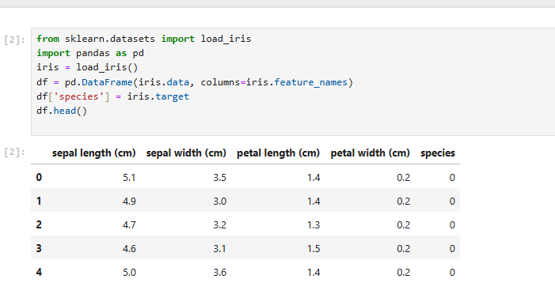

Observation Question: How many columns are there? - 5+ index

b.Task 2: Understand the Shape
df.shape

Observation Questions
- How many rows (examples)?- 150
- How many features?5
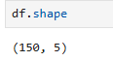

c.Task 3: Explore Columns
df.columns
df.info()

Which column is the output?
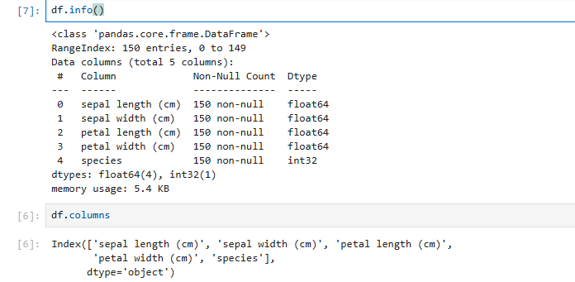

d.Task 4: Statistical Summary
df.describe()

sepal length (cm)
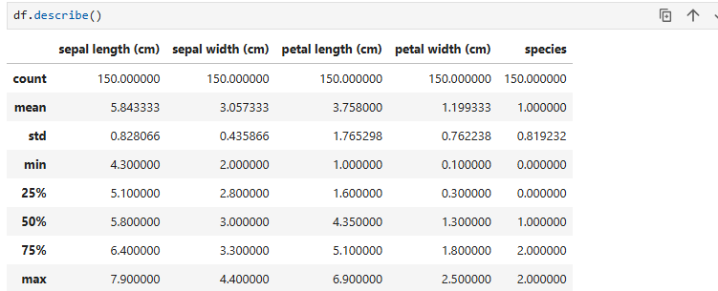

e.Task 5: Count Each Category
df['species'].value_counts()

Are classes balanced? – yes
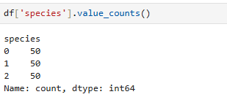

Which feature has the largest values?

f.Task 6: Plot One Graph
import matplotlib.pyplot as plt

plt.scatter(df['sepal length (cm)'], df['petal length (cm)'])
plt.xlabel("Sepal Length")
plt.ylabel("Petal Length")
plt.show()

Do you see groups forming? Yes 2
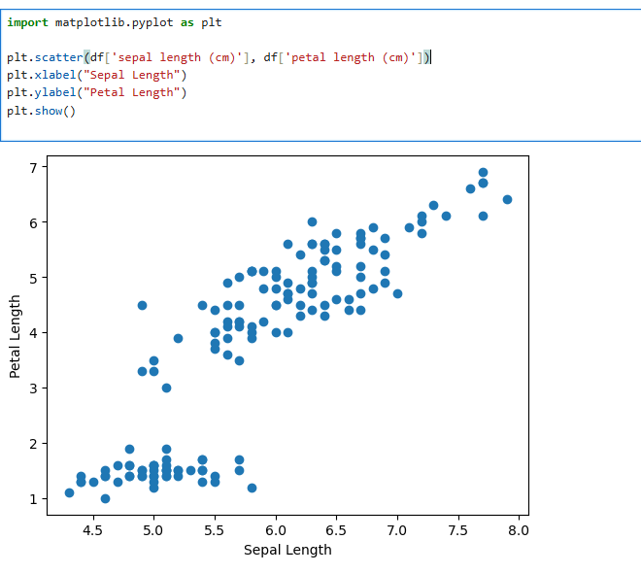

- Task 7: Compare Two Species

df[df['species'] == 0].head()
df[df['species'] == 1].head()
Do feature values differ?

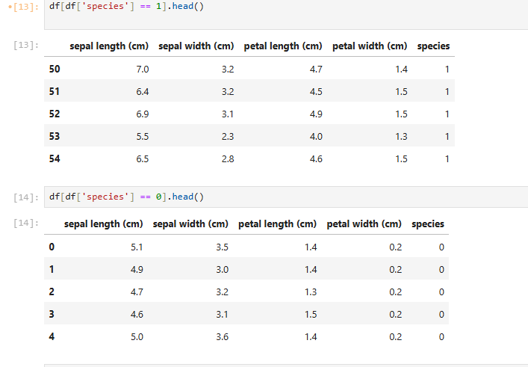
- Task 8: Correlation
df.corr()

